Name __________________________ Date _______________ Period 1 2 4 7

Isotope Activity
1) a. Fill in the spaces with what each part is indicating.
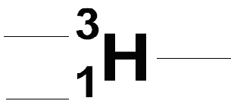
  - Fill in the following information using the image above.
Name of element | Number of protons | Number of neutrons | Number of electrons

2) Obtain a plate and a handful of each of the two types of cereal available.
3) One type will symbolize protons. Which did you pick? _______________________________
The other type will symbolize neutrons. Which did you pick? ______________________
- If you were to make the nucleus of the isotope from #1, what would the nucleus look like in cereal form? Make a combination with your cereal to represent this nucleus.
- Make two nuclei to represent the following isotopes: and 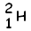.
- Let’s have a simulation of what is occurring in the sun and other stars right now! Combine the two nuclei that you made in #5 to form one isotope; what isotope would you form? Write down the shorthand notation for this isotope below.

There’s more on the back!
- What combinations of isotopes had to fuse together to create all of the elements that we know of today? See if you can figure this out using the cereal protons and neutrons to help you. Fill out the chart below. An example is given to you. See if you can predict the nuclear reactions that occurred to form the elements up to iron. You can use a periodic table to help you.
Isotope #1 | Isotope #2 | Resulting Isotope | Element Name | Protons | Neutrons | Electrons
 |  | 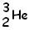
Name __________________________ Date _______________ Period 1 2 4 7

“Hunting the Elements” Tracker
Directions: As you are watching the video, keep track of your notes with this tracker.
Time Elapsed | Notes

Name __________________________ Date _______________

Documentary Tracker
Directions: What documentary did you end up choosing to watch? ________________________
As you are watching the video, keep track of your notes with this tracker.
Time Elapsed | Notes

